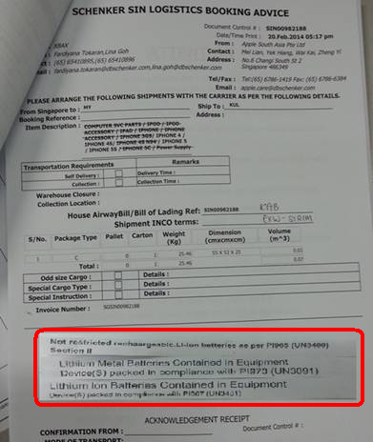

Please refer to the below for 3 categories:

1. Not restricted rechargeable. LI-ion batteries as per PI965 (UN3480) Section II
2. Lithium Ion Batteries Contained in Equipment

Device(S) packed in compliance with PI967 (UN3481)

1. Lithium Metal Batteries Contained in Equipment

Device(S) packed in compliance with PI970 (UN3091)